
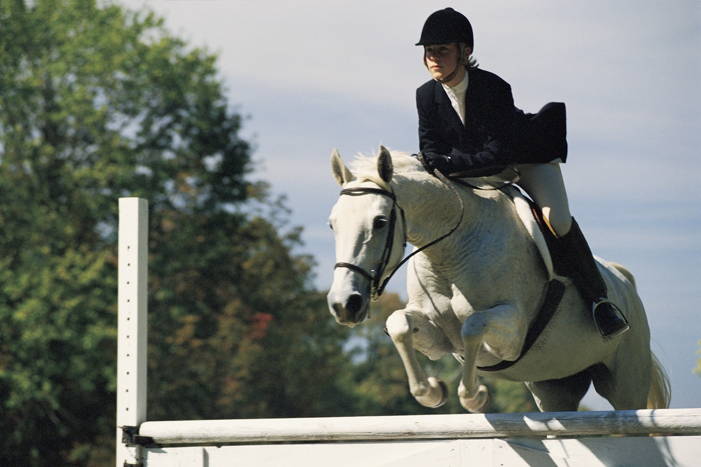
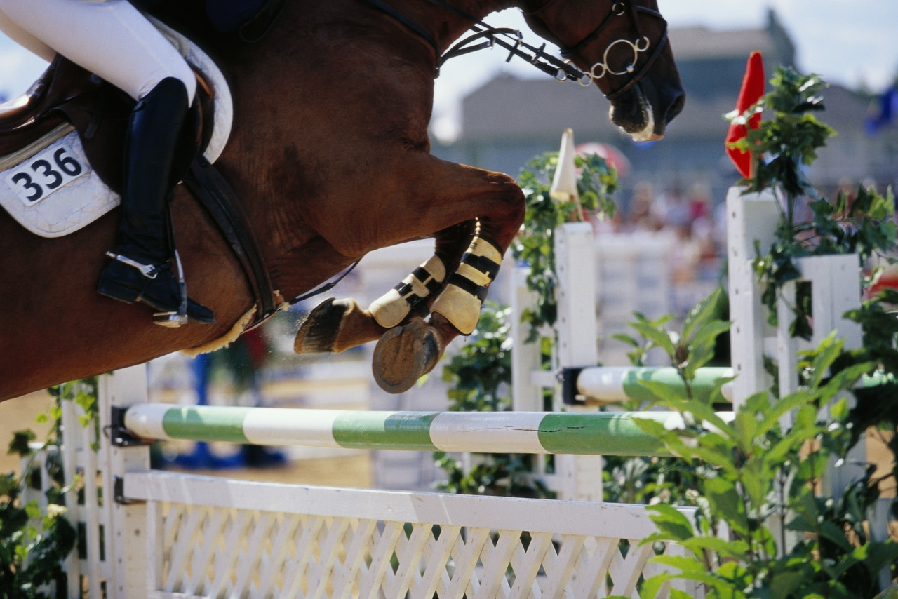

Annual Interschools Showjumping
Saturday 17th February 2018
Schedule Of Events

Sponsored by TRI Equestrian & Boswell Equestrian Centre

At Boswell Equestrian
Ashford, Killiskey, Co Wicklow
Team & Individual Showjumping Event

Arena 1- Main All Weather- Course walk 9.00am
Start Time 9.30am Sharp
Class | Prize Fund | Entry
1. Open Team Event – 95cm - 1m | In Kind | €80 Team
2. Open Individuals – 95cm - 1m | In Kind | €15
3. HSI 1.10m Premier Class | In Kind | €20
Arena 2- Top Arena- Course walk 9.00am
Start Time 9.30am Sharp
Class | Prize Fund | Entry
4. Novice Team Event – 80cms | In Kind | €80 Team
5. Novice Individual -80cms | In Kind | €15
6. Primary School Team Event–65cms | In Kind | €80 Team
Primary riders can compete in the Novice Individuals with permission from their Chef D’equipe
Entries Close Thursday 15th at 10am Sharp.
Enquiries to Boswell Equestrian on 087-1303959
info@boswellequestrian.ie

